# System Infrastructure Diagram

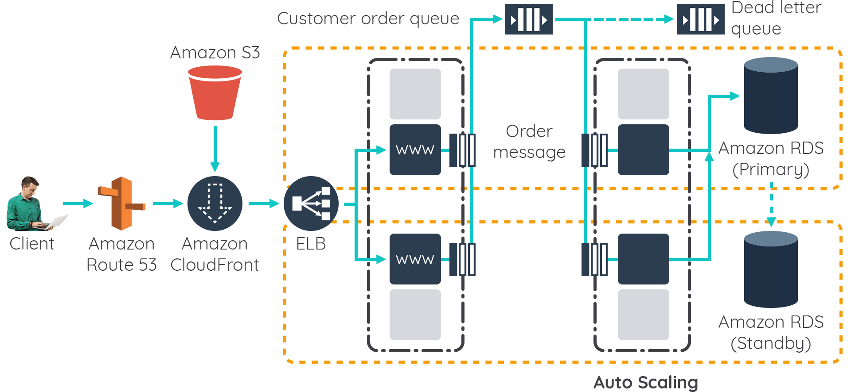



# Technology Stack

DevOps

GitHub

AWS

CI/CD

Front-End

React.js

webpack

HTML, CSS3,SASS

Back-End

Javascript

Environment

RabbitMQ

AWS Cloud Watch

Jest.js

AWS EC2 Instance

AWS S3

Database

MySQL

MongoDB

Redis

Elasticsearch

DevOps

Gitlab

AWS

CI/CD

Nginx

Hapi.js

Node.js

# Security

* SQL Injection
  + Parameterized Query
  + Object Relational Mapping (ORM)
* Browser Security
  + CORS dari Sisi Server
* Denial of Service
  + Nginx Rate Limiter di AWS EC2 Instance
  + Limit Access pada Nginx

# Monitoring

AWS Cloud Watch Untuk monitoring service

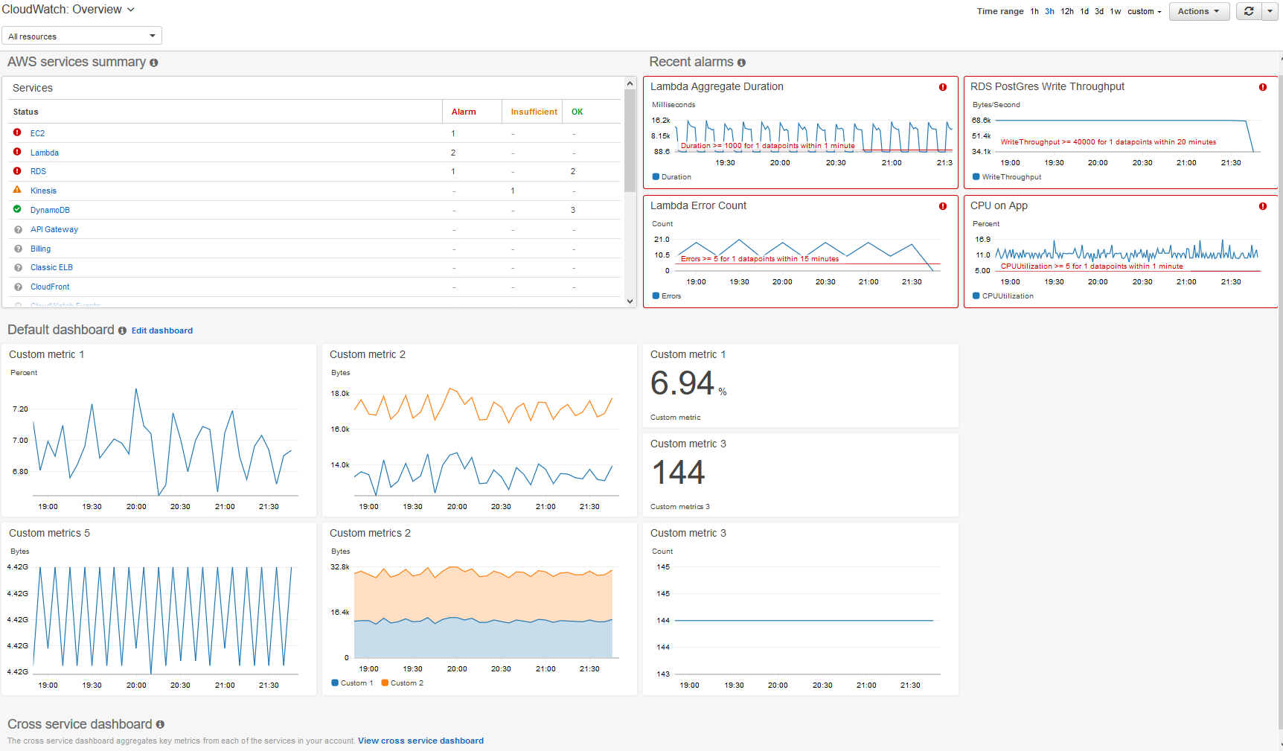

# Integration and deployment strategy

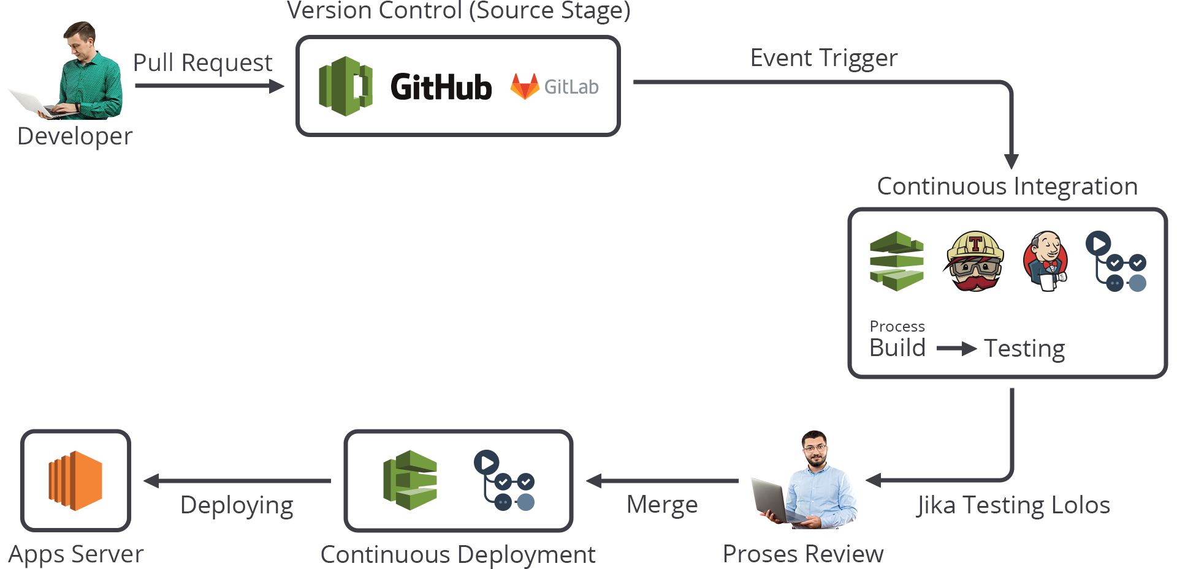

Platform CI/CD

